Assumptions and changes

1. Realized the cardinality of relationships with Favourites did not make sense as binary N:M relationships. Thus, we changed them to binary 1:N relationships.
2. Changed the Admin from a weak entity to a specialized subclass of User.
3. 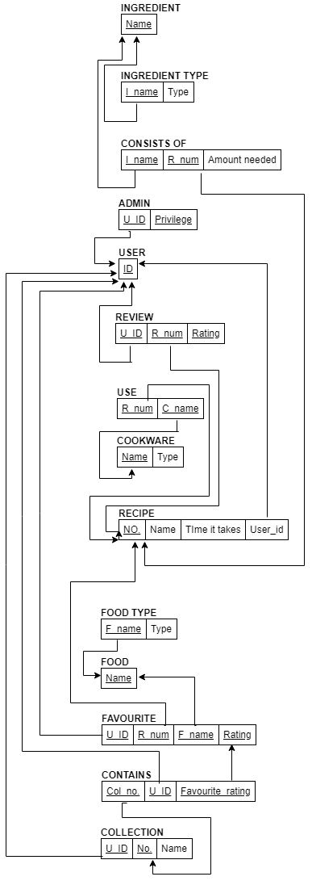Added an extra attribute to Collection to help identify it.